
Lesson 14 Teacher's Key: Raising the Stakes
GDevelop - Instructor Reference Only
VIDEO GAME CREATION

What This Lesson Teaches
Same idea as every engine this week - replace hardcoded literals with wave-dependent formulas - expressed as GDevelop expressions inside the Setup and advance-wave events built since Lesson 10/11.

Level 1 - Full Worked Solution
- (4 + Wave) as a repeat count and as EnemiesRemaining's reset value must be identical in BOTH the Setup event group and the advance-wave event - two places, one formula, each independently editable, so both need checking.
- No new variables are needed for Level 1 - this is purely an expression change inside events that already exist.
- Wave 1 still spawns exactly 5 (4 + 1 = 5), so nothing about the game's opening feel changes - only later waves escalate.
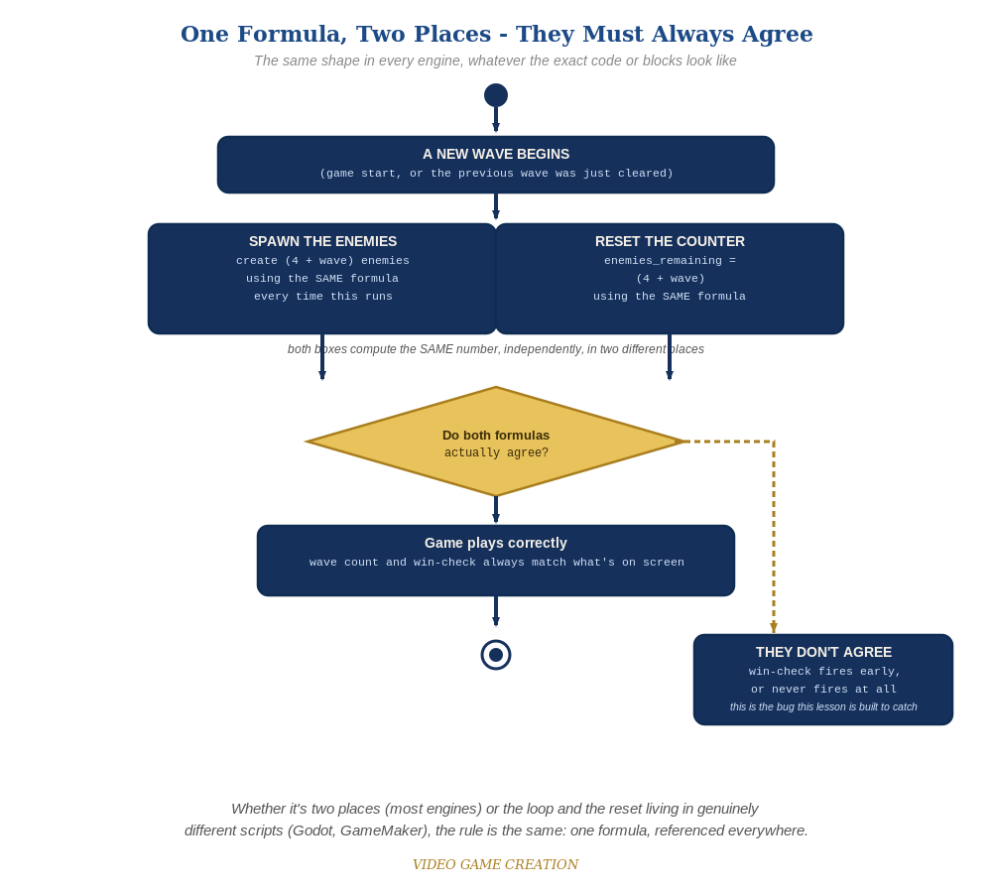
Whether the spawn loop and the reset live in two places or two genuinely different scripts, the rule is the same: one formula, referenced everywhere.

Why This Structure
- GDevelop's expression fields accept the SAME formula ((4 + Wave)) typed directly wherever a number is expected - no separate 'store it in a variable first' step is required the way GameMaker's or Unity's code needed, though it's still good practice to double check both events agree.
- For Level 2, adding a Speed object variable to Enemy (rather than a scene-wide variable) keeps each enemy's speed as its own property, consistent with how Score/Lives/Wave are scene-wide but per-enemy state (like position) has always lived on the object itself.

Level 2 / Level 3 Talking Points
- Ask students to find both places (4 + Wave) needs to appear (Setup group, advance-wave event) and confirm they're both actually updated - a good comprehension check for events versus a single function.
- For students comparing engines: point out that Scratch's identical (4 + wave) formula, expressed as blocks instead of GDevelop's expression fields, is conceptually the exact same idea.

Common Student Mistakes
- Updating the Setup group's formula but forgetting the advance-wave event's matching formula (or vice versa) - these are two separate events since Lesson 11, easy to update only one.
- Adding Speed as a scene variable instead of an object variable on Enemy, which would give every enemy the SAME speed rather than each one carrying its own.
- Forgetting to change the Enemy's movement action to read Enemy.Variable(Speed), leaving it at a hardcoded number.

